Nagios Core Configuration with Email Alerts

1. **Install Nagios Core Server**

sudo sed -i 's/SELINUX=.*/SELINUX=disabled/g' /etc/selinux/config

sudo setenforce 0

sudo yum install -y gcc glibc glibc-common wget unzip httpd php php-cli gd gd-devel openssl-devel net-snmp perl -y

sudo yum install -y make gettext autoconf net-snmp-utils epel-release automake tar wget

cd /tmp

wget -O nagioscore.tar.gz [https://assets.nagios.com/downloads/nagioscore/releases/nagios-4.5.8.tar.gz](https://assets.nagios.com/downloads/nagioscore/releases/nagios-4.5.0.tar.gz)

tar xzf nagioscore.tar.gz

cd nagios-4.5.8

sudo ./configure

sudo make all

sudo make install-groups-users

sudo usermod -a -G nagios apache

sudo make install

sudo make install-commandmode

sudo make install-config

sudo make install-webconf

sudo make install-daemoninit

sudo systemctl enable httpd.service

sudo firewall-cmd --zone=public --add-port=80/tcp

sudo firewall-cmd --zone=public --add-port=80/tcp --permanent

sudo htpasswd -c /usr/local/nagios/etc/htpasswd.users nagiosadmin

sudo systemctl start httpd

1. **Install Nagios Plugins on the Nagios Server**

sudo yum install -y make gettext automake autoconf wget openssl-devel net-snmp net-snmp-utils epel-release

sudo yum install -y perl-Net-SNMP

cd /tmp

wget --no-check-certificate -O nagios-plugins.tar.gz <https://github.com/nagios-plugins/nagios-plugins/archive/release-2.2.1.tar.gz>

tar zxf nagios-plugins.tar.gz

cd /tmp/nagios-plugins-release-2.2.1/

sudo ./tools/setup

sudo ./configure

sudo make

sudo make install

1. **Download and add the check_ncpa.py plugin on the Nagios Server**

Press cd to go the user home directory.

cd

wget https://assets.nagios.com/downloads/ncpa/check_ncpa.tar.gz

tar xvzf check_ncpa.tar.gz

sudo cp check_ncpa.py /usr/local/nagios/libexec/

1. Define command for check_ncpa

Nagios server uses commands defined in the commands.cfg file. Thus we need to define the command for ncpa plugin in this file.

sudo vi /usr/local/nagios/etc/objects/commands.cfg

Add following lines in this file. You can add these lines anywhere in the file.

define command {

command_name check_ncpa

command_line $USER1$/check_ncpa.py -H $HOSTADDRESS$ $ARG1$

}

Save the file.

1. **Define client information and the services to monitor on the client.**

Find out the IP address of the client. Enable the servers directory configuration files in the Nagios configuration file. Then in the servers directory define the the client configuration files for monitoring.

sudo vi /usr/local/nagios/etc/nagios.cfg

Go to line 51 and remove # as shown below.



Save the file.

Now create the servers directory.

sudo mkdir /usr/local/nagios/etc/servers

Now create the client configuration file in this directory for monitoring.

sudo vi /usr/local/nagios/etc/servers/rocky1.cfg

First define following in the file.

define host {

use linux-server

host_name rocky1

alias rocky1

address 192.168.232.135

}

**Change the IP address and host name to match your client information.**

Next add following to monitor services. **Change host name to match your client hostname.**

define service {

host_name rocky1

service_description CPU Usage

check_command check_ncpa!-t 'ditissdemo25' -P 5693 -M cpu/percent -w 20 -c 40 -q 'aggregate=avg'

max_check_attempts 5

check_interval 5

retry_interval 1

check_period 24x7

**notification_interval 60**

**notification_period 24x7**

**contacts nagiosadmin**

register 1

}

define service {

host_name rocky1

service_description Memory Usage

check_command check_ncpa!-t 'ditissdemo25' -P 5693 -M memory/virtual -w 50 -c 80 -u G

max_check_attempts 5

check_interval 5

retry_interval 1

check_period 24x7

**notification_interval 60**

**notification_period 24x7**

**contacts nagiosadmin**

register 1

}

The settings shown in colour are needed for Nagios to inform the events related to this service by email to user. Here nagiosadmin is the user who will receive the email. You can change the notification interval as per your requirements.

Save the file.

1. **Configure postfix email server**

On the nagios server we will install the postfix serve and configure it.

sudo yum install postfix -y

Once the postfix is installed configure it.

sudo vi /etc/postfix/main.cf

Make following changes.

Remove # and specify your domain name.



Remove # from following line.



Remove # from ;ine 132 and add # to line 135

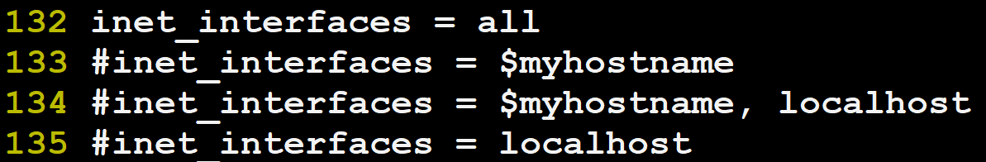

Put # to line 183. Remove # from line 184.



Remove any other network and add your network as shown below.



Remove # from line 438 to enable Maildir type mailbox.

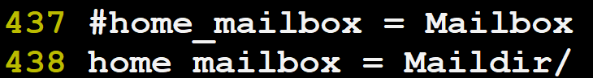

Save the file.

sudo systemctl start postfix

sudo systemctl status postfix

sudo systemctl enable postfix

sudo useradd nsadmin

sudo passwd nsadmin

1. **Define email address for nagiosadmin user.**

Sudo vi /usr/local/nagios/etc/objects/contacts.cfg

In this file add email address for nagiosadmin user. This email id will be of the user created above.

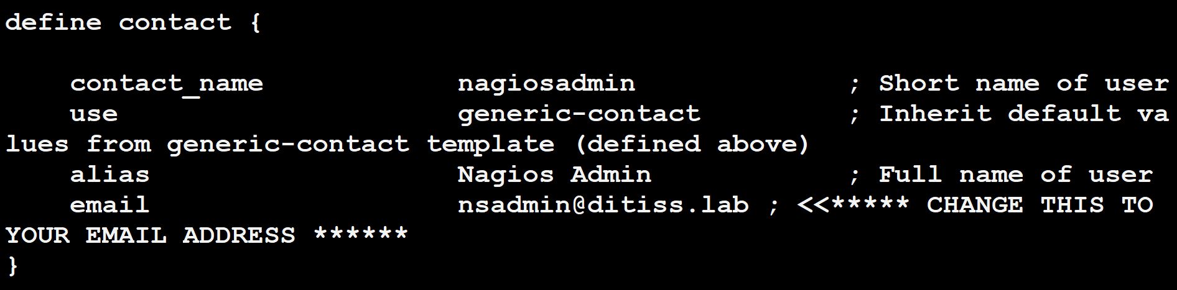

Save the file.

1. **Verify that the email notification command is enabled in the nagios commands.cfg file.**

It is by default enabled.

sudo vi /usr/local/nagios/etc/objects/commands.cfg

These commands are on line 26.

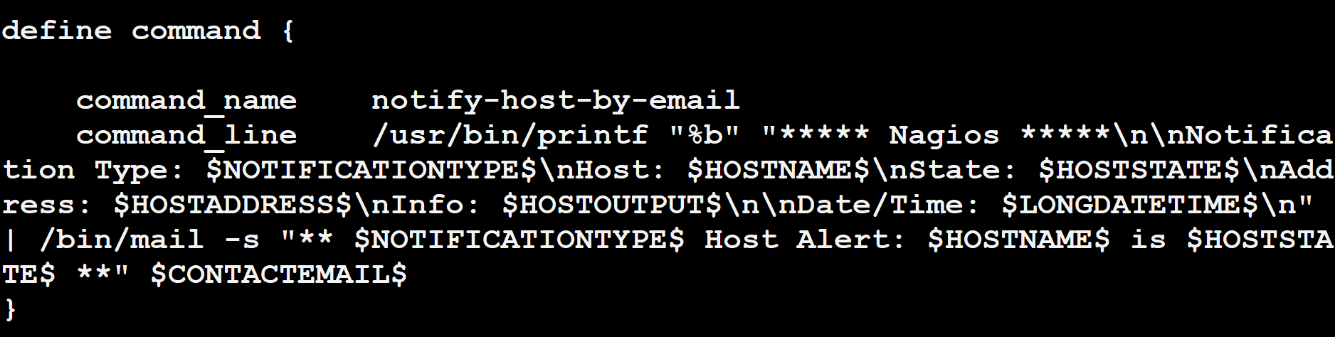

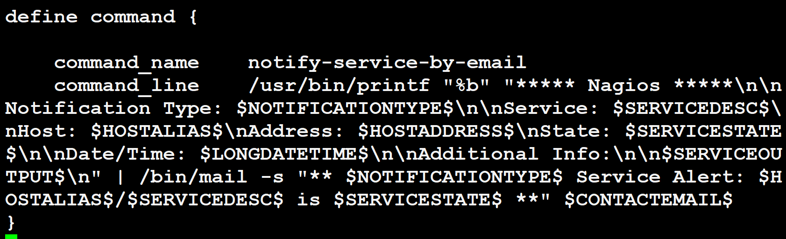

These are the 2 commands used to send email notifications. You can modify the information that will be sent in the email.

1. Verify nagios configuration and start the service.

sudo /usr/local/nagios/bin/nagios -v /usr/local/nagios/etc/nagios.cfg

If evrything is Ok. Then start the nagios service.

sudo systemctl start nagios

sudo systemctl status nagios

sudo systemctl enable nagios

1. **Install ncpa plugin on client and configure.**

Login to the client server. Now install ncpa plugin.

sudo rpm -Uvh <https://repo.nagios.com/nagios/9/nagios-repo-9-2.el9.noarch.rpm>

sudo yum update

sudo yum install ncpa

Once the installation finishes. Add token to the NCPA file. Edit the ncpa configuration file.

Also you need to open the TCP port 5693 used by ncpa plugin.

sudo vi /usr/local/ncpa/etc/ncpa.cfg

Go to line 203 and provide your token in community_string.



Save the file.

Start the ncpa service.

sudo systemctl start ncpa

sudo systemctl status ncpa

sudo systemctl enable ncpa.

sudo firewall-cmd --add-port=5693/tcp

sudo firewall-cmd --add-port=5693/tcp --permanent

Now in the browser on Windows type <https://client-ip:5693>

You should be able to get the ncpa website.

1. **Update the above token in the Nagios server configuration file.**

Login to Nagios server. Edit the client configuration file.

sudo vi /usr/local/nagios/etc/servers/rocky1.cfg

In the define service section, in the check_ncpa command specify your token after -t .

define service {

host_name rocky1

service_description CPU Usage

check_command check_ncpa! -t 'ditissdemo25' -P 5693 -M cpu/percent -w 20 -c 40 -q 'aggregate=avg'

Make sure you update the token for all services.

Save the file.

Verify nagios configuration.

sudo /usr/local/nagios/bin/nagios -v /usr/local/nagios/etc/nagios.cfg

If everything is Ok then restart the nagios service.

sudo systemctl restart nagios

Once the service starts successfully. Go to the nagios dashboard.

<http://nagios-server-ip/nagios.> # put your server IP here

Login as nagiosadmin and provide password given during Nagios server installation.

Make sure the localhost and client and there services are shown properly.

1. Verify email is received.

Go to the client.

sudo yum install stress -y

Once the package is installed give the following command.

sudo stress --cpu 2 -t 50

Now go to the nagios dashboard and check CPU and number od processes for the client.

On the server terminal type

su - nsadmin

Provide password.

In user home directory you will find a directory by name Maildir.

cd Maildir/new

Do ls. You will find a file starting with a number. Use cat to check the contents of the file. This will be the email sent by the nagios server.